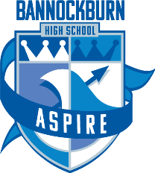
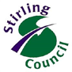

16 March 2020

Dear Parent,

As I am sure you are aware there continues to be uncertainty around what may happen over the next few weeks in relation to the coronavirus. At the moment there are no plans to close schools but we need to look at several contingency plans should the advice on this change.

We have been working on three key areas:

- Learning Contingency Plans
- Senior Phase Students
- Pastoral Support Contingency Plans

We will continue to update you with progress on these areas and share information as and when we have it e.g. SQA information.

As ever, your best source of information is the NHS Inform site, which you can reach here: https://www.nhsinform.scot/illnesses-and-conditions/infections-and-poisoning/coronavirus-covid-19

From today 16.3.20, the following will be cancelled in line with Stirling Council advice:

Parents’ Evenings
Bannockburn’s Got Talent
Our End of Term Service (held in the school on the last day of term)
S4-S6 Community Study Sessions held in Bannockburn High School from 5-7pm
Assemblies
All afterschool clubs
Sports events
Battlefields Trip (further information to follow)
Transition activities from P7 to S1
External meetings (including Parent Council)
Visitors to school for educational purposes
Duke of Edinburgh Expeditions
Volunteers in school

Supported Study will continue where possible. Senior students will be kept up-to-date in relation to Supported Study.

Yours faithfully,

K Hook
Head Teacher

