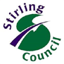
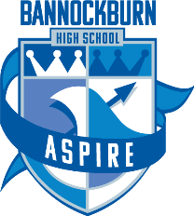

18 March 2020

Dear Parents and Carers,

It is understandable that everyone has concerns at this time regarding Coronavirus. We continue to follow the advice of the Government and Health Professionals. We are all acutely aware of the developing situation and advice from the Scottish Government and health authorities which are constantly being updated.

At this time schools and nurseries remain open. The Government is reviewing that on a daily basis and the situation is clearly evolving.

It is important to reinforce that the recommendations for social distancing that have been set out by the Government apply to pupils and nursery children, as well as adults.

The guidance is clear: a child or young person with any underlying health issues should adhere to social distancing advice. If children live in a household where family members display symptoms, then every member of the family should self-isolate for 14 days.

Staff members may also be unable to attend the workplace at this time by following the above guidance. Therefore, following national advice, at this time class sizes may increase and children may be taught by a member of staff who is not their regular class teacher.

Thank you to everyone for your continuing support with this matter. We will update parents with any further information as soon as it is available.

Yours faithfully

K Hook
Head Teacher

