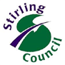
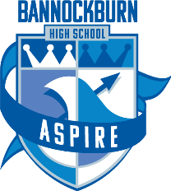

23 March 2020

Dear Parent,

Following the First Minister’s announcement yesterday, which made clear that ALL pupils (including those from S4-S6 ) should be working from home, please see below the following advice:

Pupils S1-S3
Pupils in S1 – S3 should continue to access their learning through Google Classroom. Individual teachers and departments will be posting work for pupils to complete. Please note that pupils should not feel that they must complete every task and should work at their own pace with regular breaks.

Students S4-S6
We await further communication and guidance from the SQA and as soon as we are able to, we will share further updates with you. In the meantime, students in S4-S6 should continue to complete work for assignments at home, if they are well enough to do so, and liaise with their teachers through Google Classroom. Clearly, only some assignment work can be completed at home and we will issue further advice in relation to those assignments which cannot be completed at home when we have received it from the SQA. Students should work through what they can, at their own pace and be guided by their teachers in relation to deadlines.

We realise that this is a challenging time for all but putting the health of yourself, your families and our community is paramount at this time.

We will update you as soon as we can.

Stay safe.

Kind regards,

Karen Hook
Head Teacher

